**Question: Using RapidMiner find TF_IDF value for this purpose we need to perform the foloowing steps**

Step1: Create a Repository choose new local repository and you can use any name you want we create a respoitory name **TextAnalysis_TFIDF**

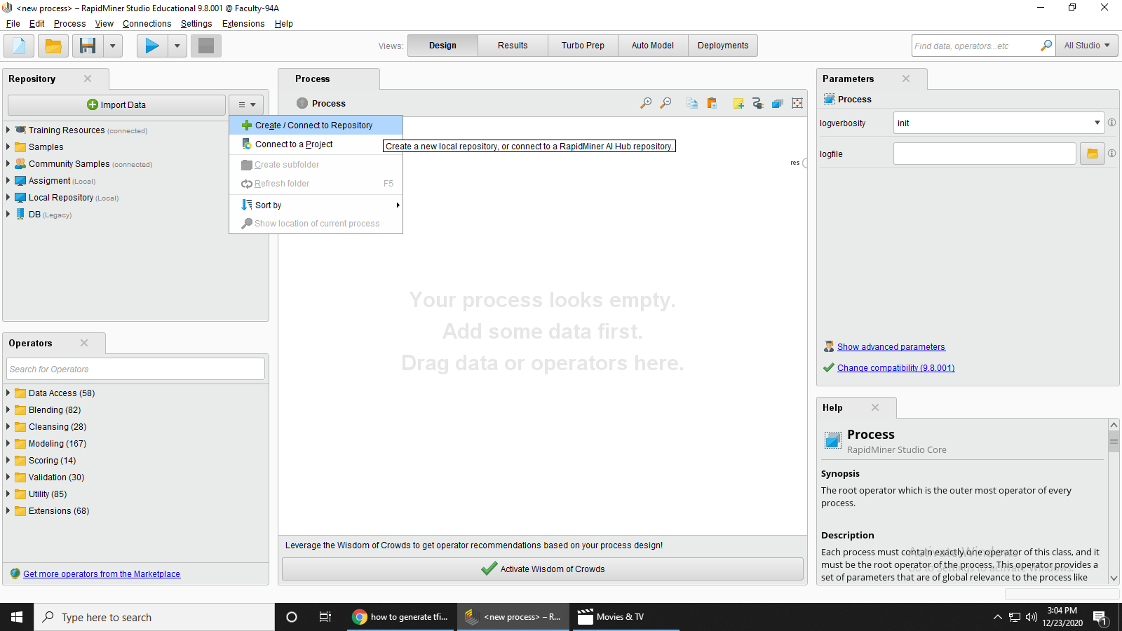

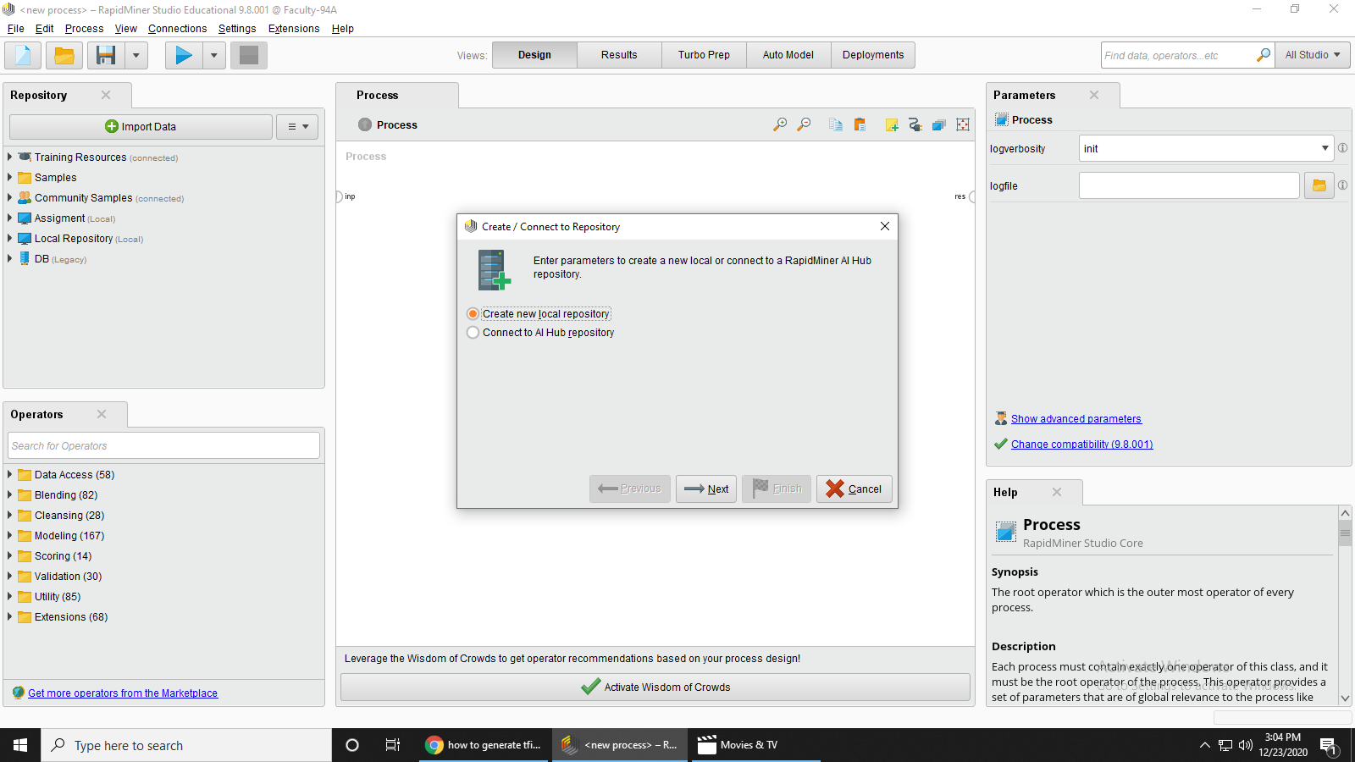

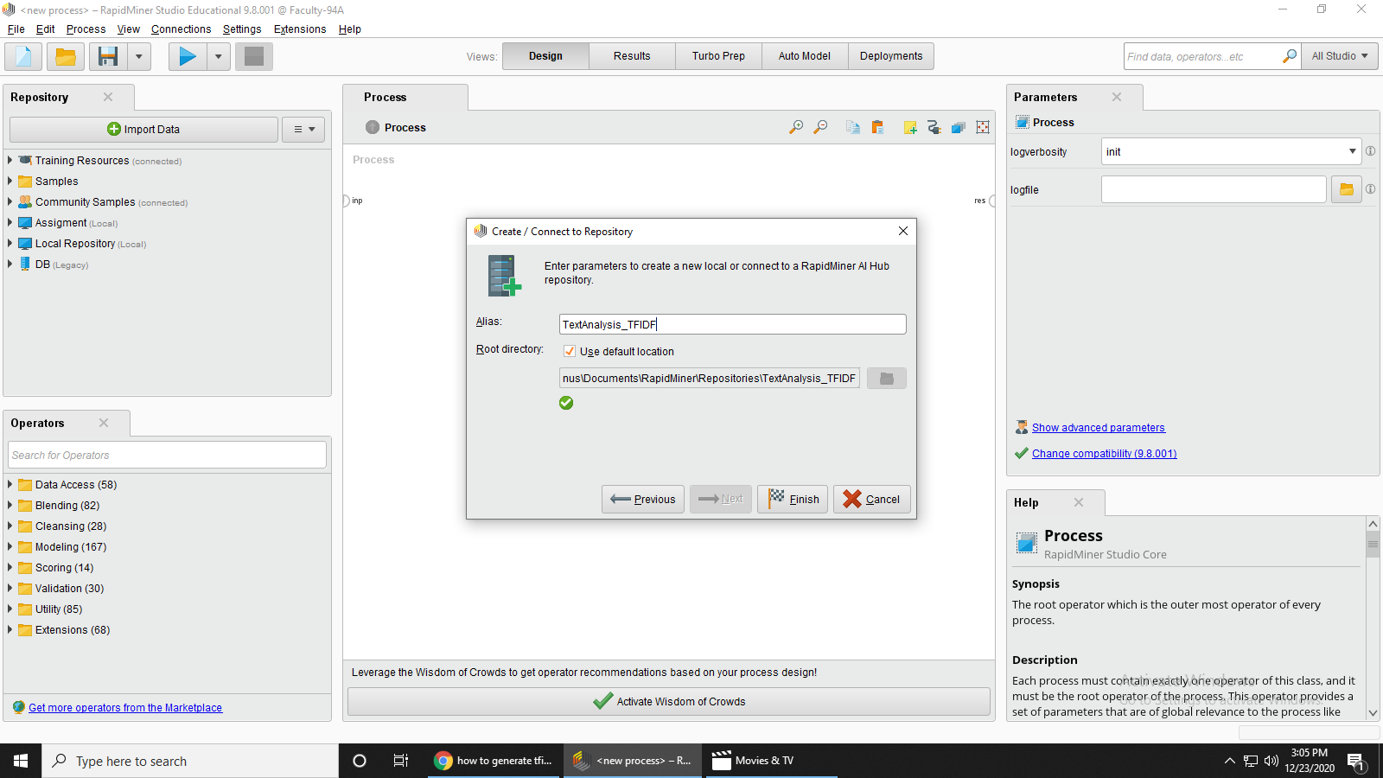

Step 2: Now you can Right click on your repository and create Store Process. Here the name of the process is **TextFind_TFIDF**

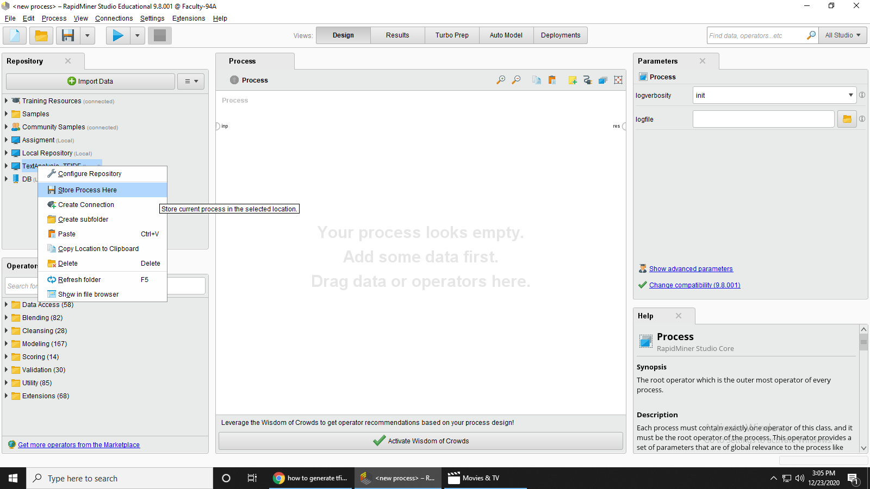

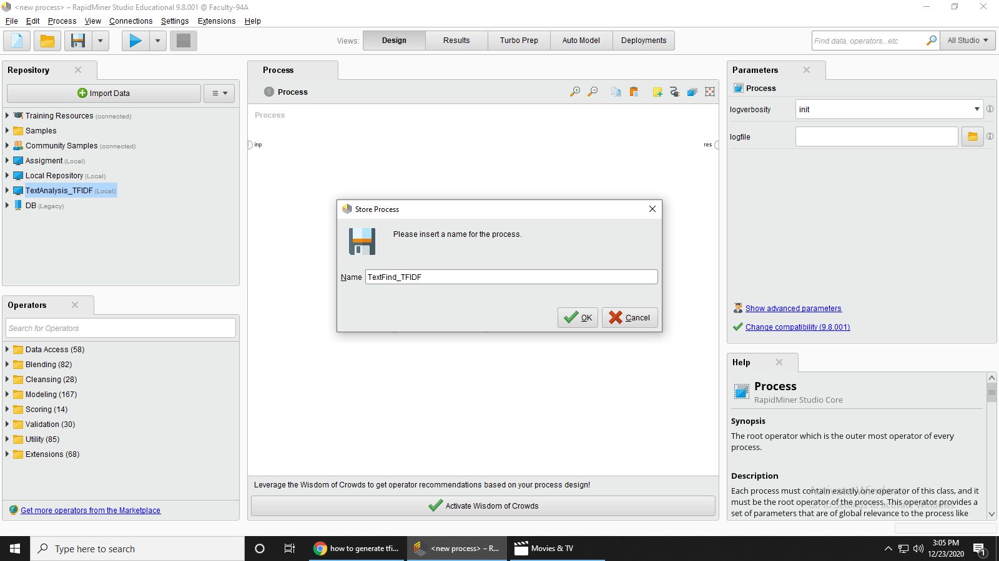

Step 3: Now go to the operator and pick the **“Read Excel Operator”**

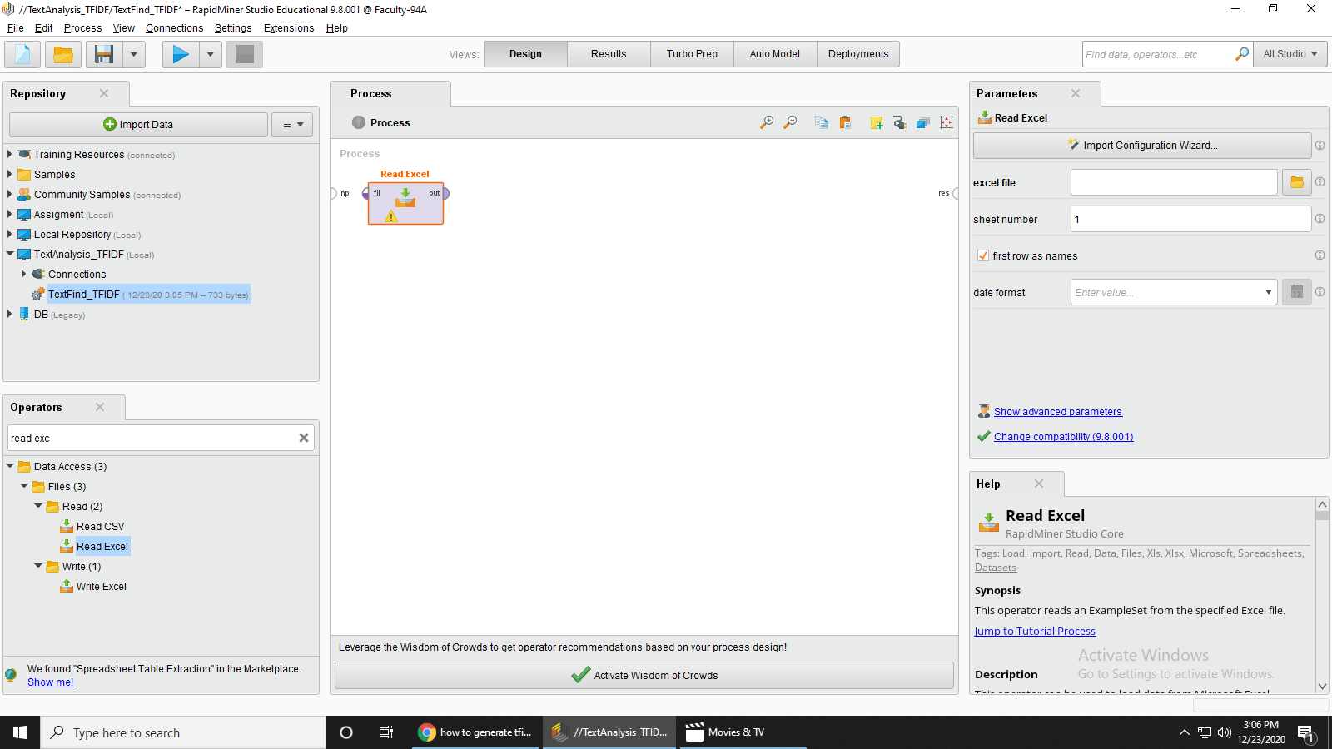



Step 3: Choose excel file in this we place some text data

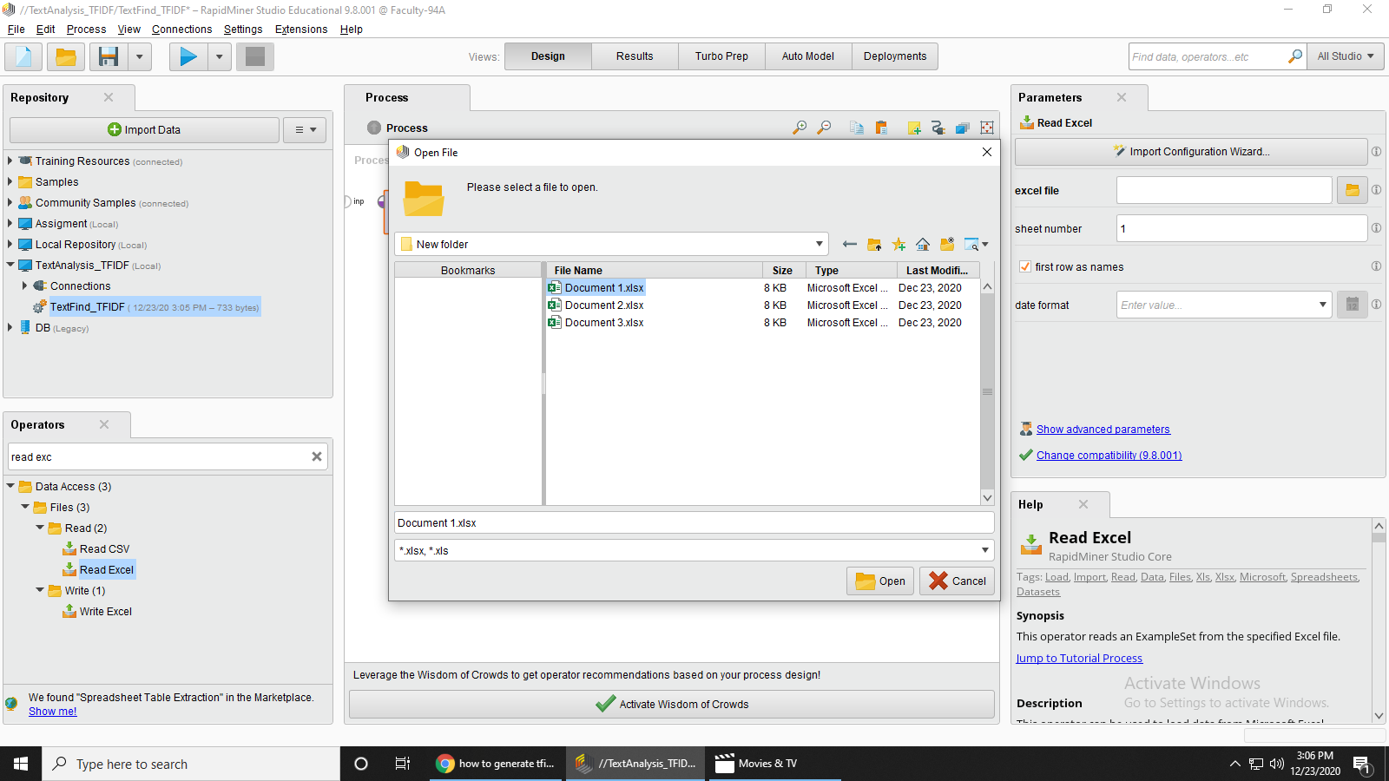



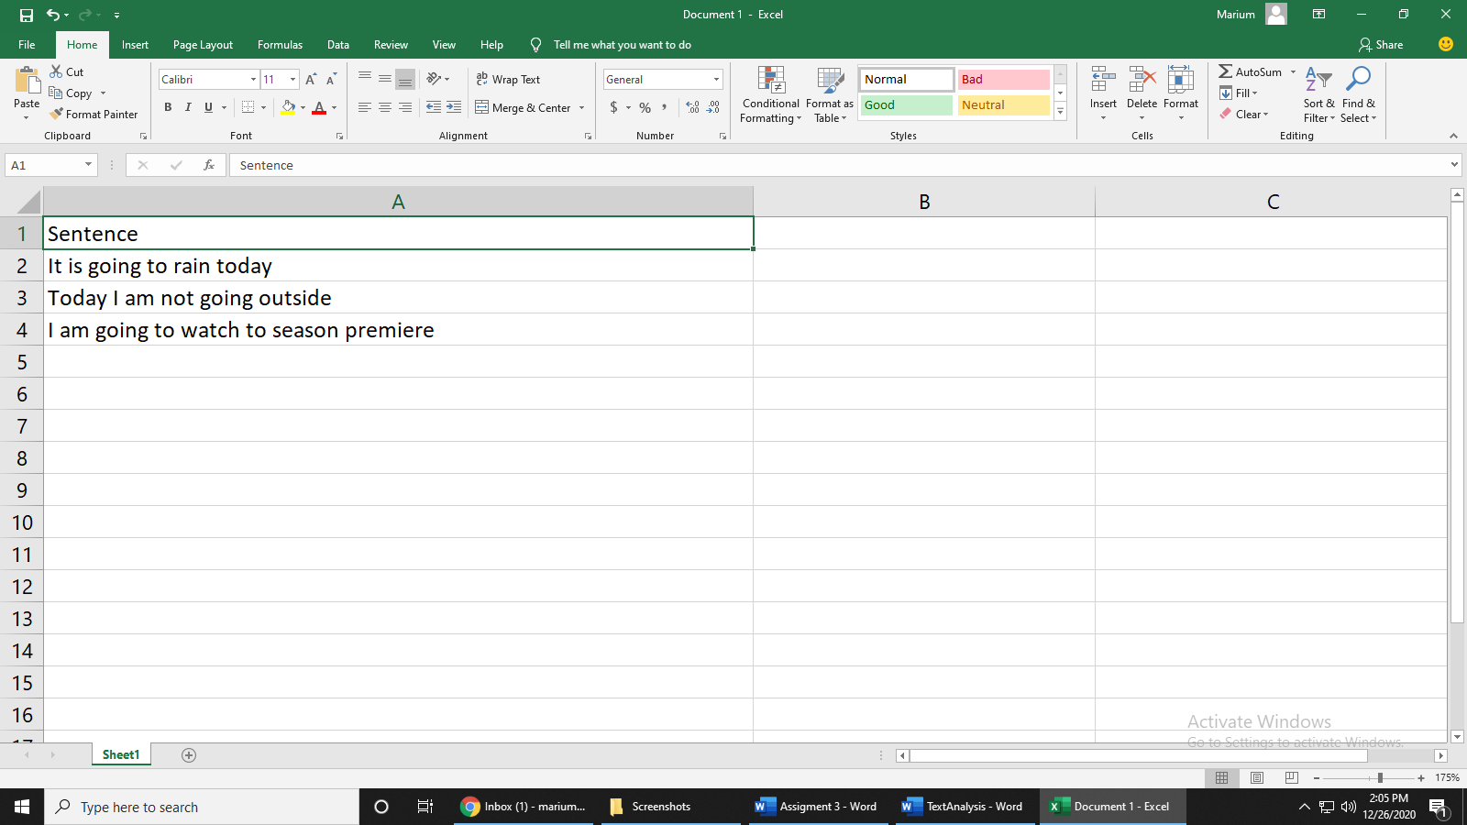

Step 4: Now go to the operator and pick the **“Split Operator”**

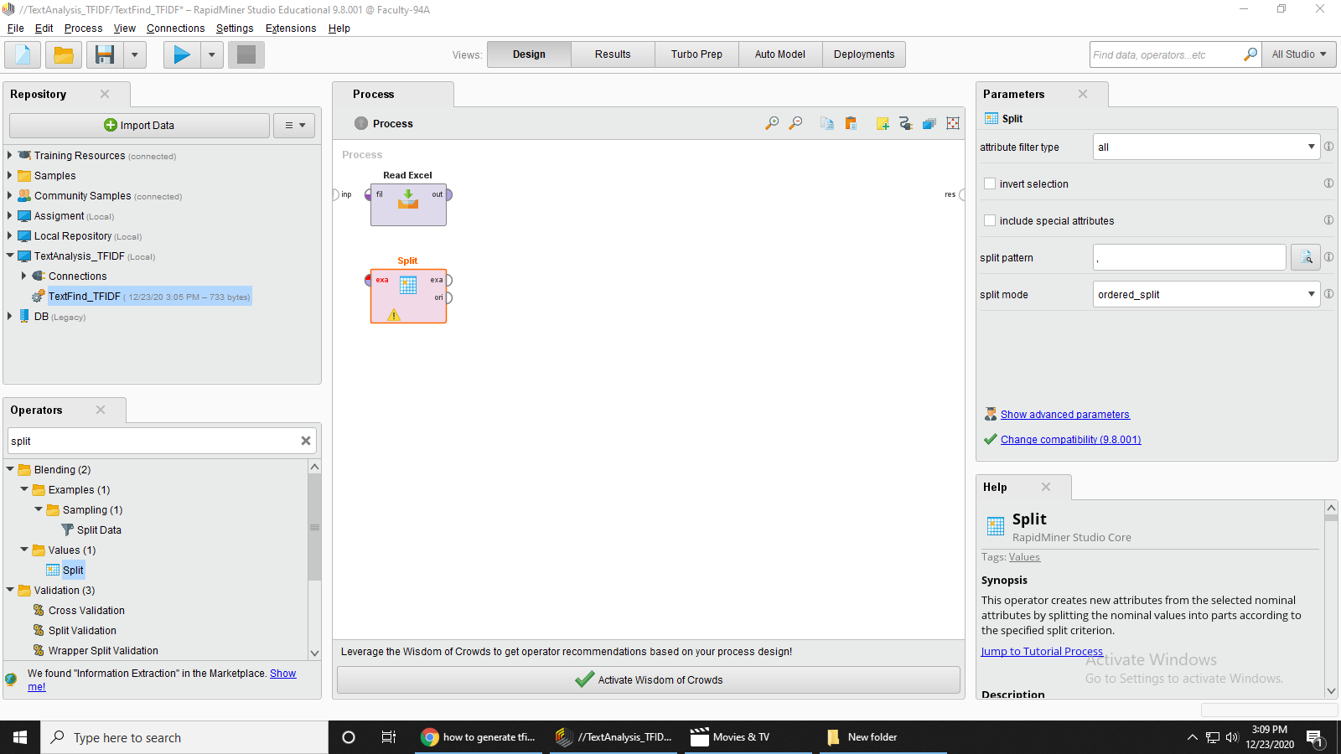



Step 5: Now go to the operator and pick the **“Select Attributes Operator”**

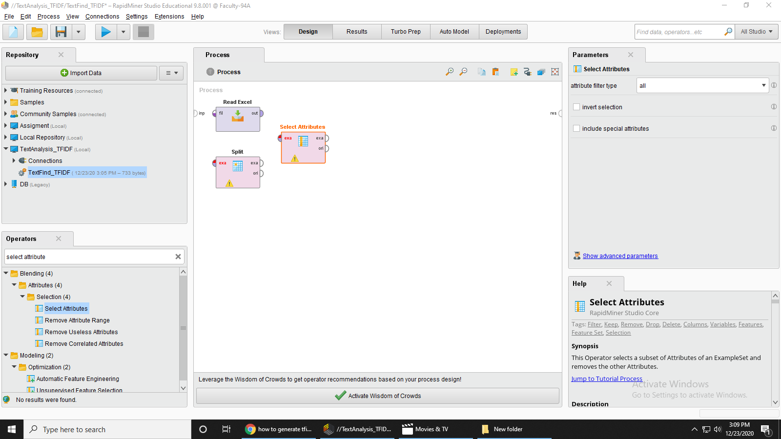



Step 6: Now go to the operator and pick the **“Select Attributes Operator”**

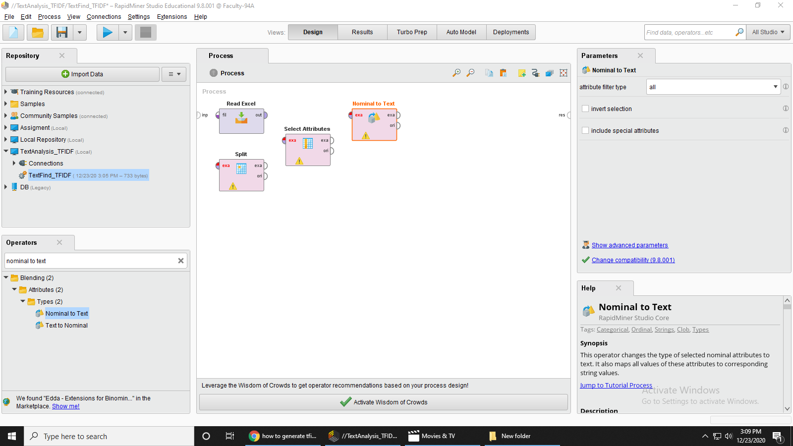



Step 7: Now go to the operator and pick the **“Data to Document Operator”**

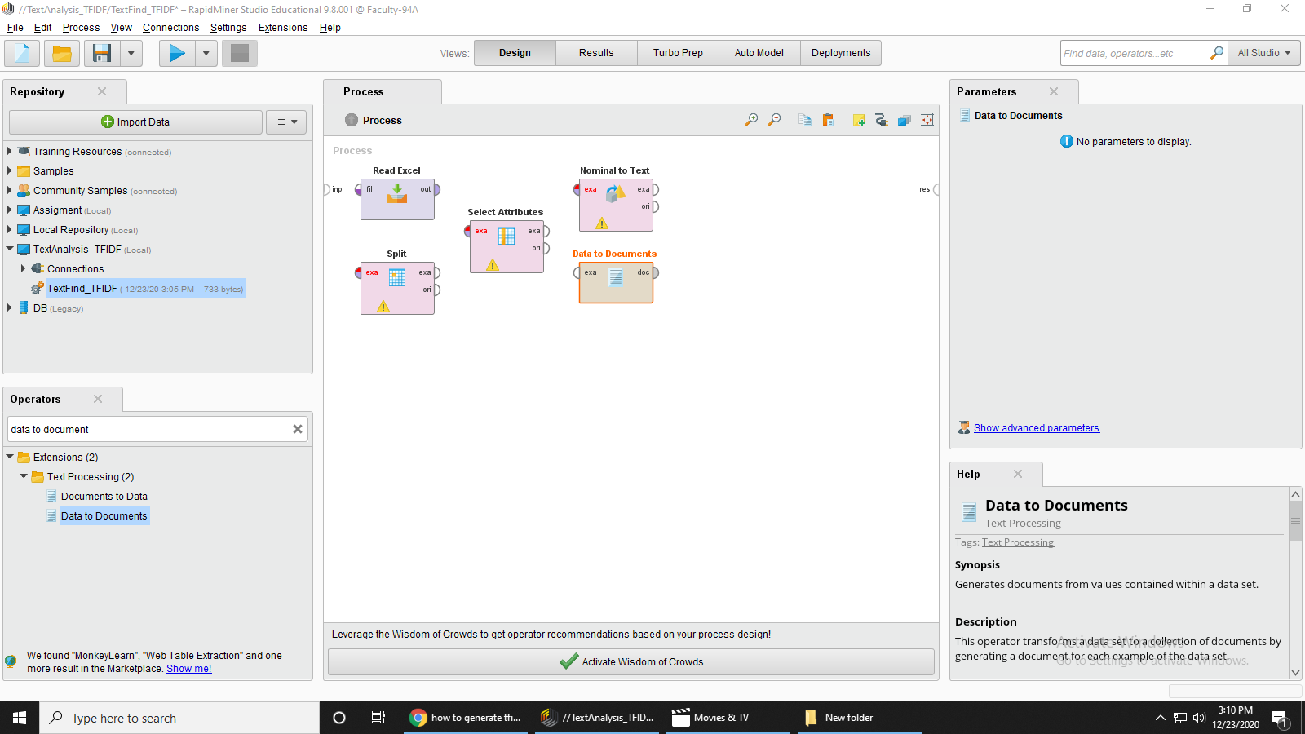



Step 8: Now go to the operator and pick the **“Process Documents Operator”**

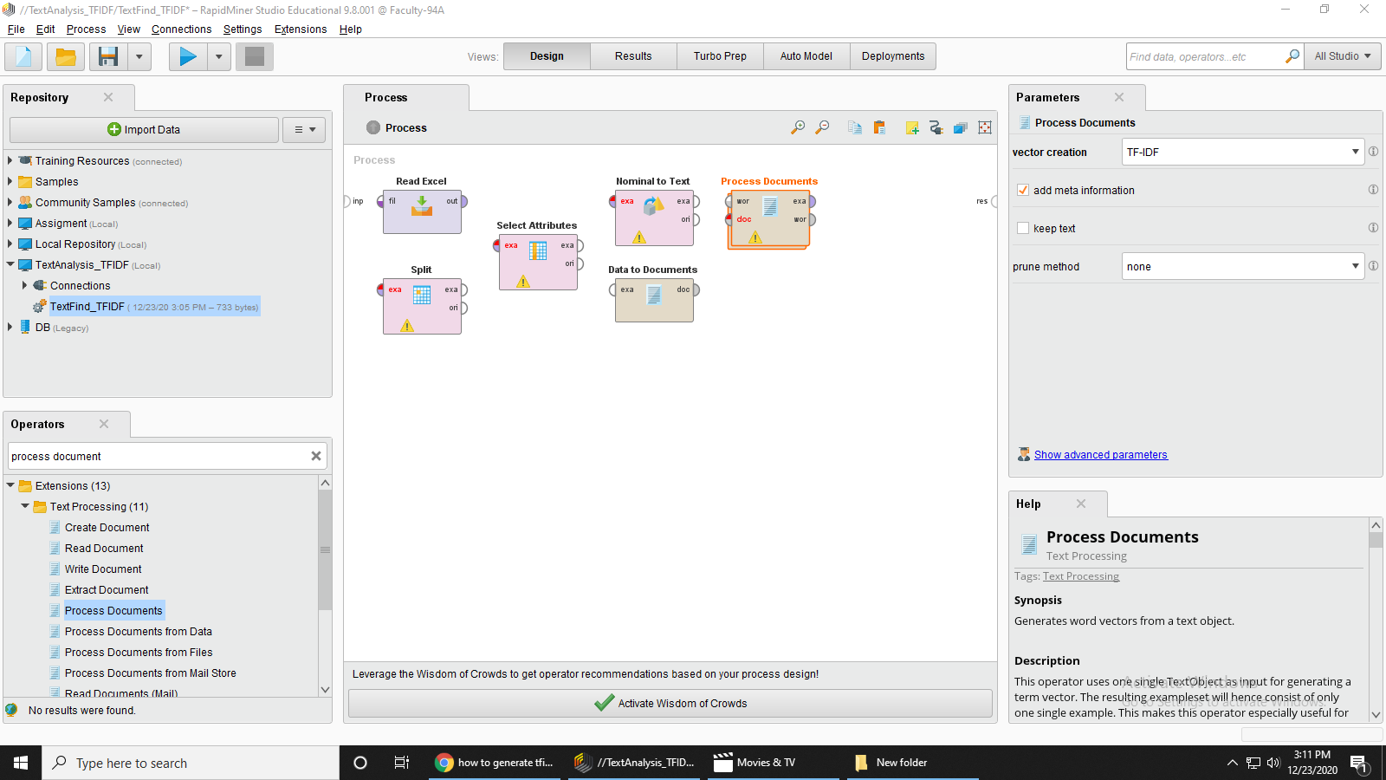



Step 9: Now go to the operator and pick the **“Multiply Operator”**

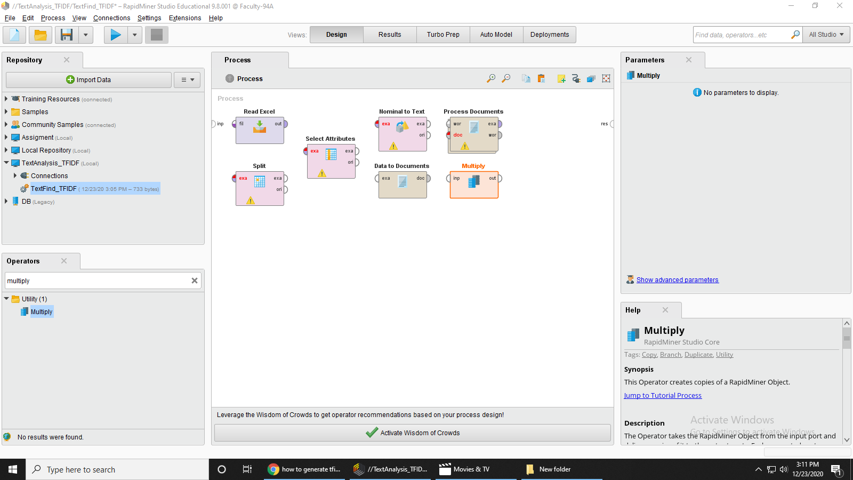



Step 10: Now go to the operator and pick the **“Generate TFIDF Operator”**

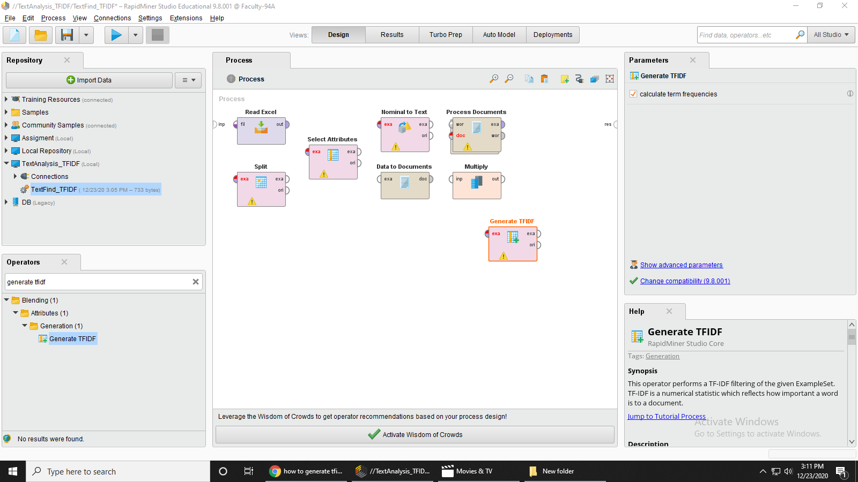



Step 10: Tokenization process double click on process document and then add **“Tokenize operator”** on it.

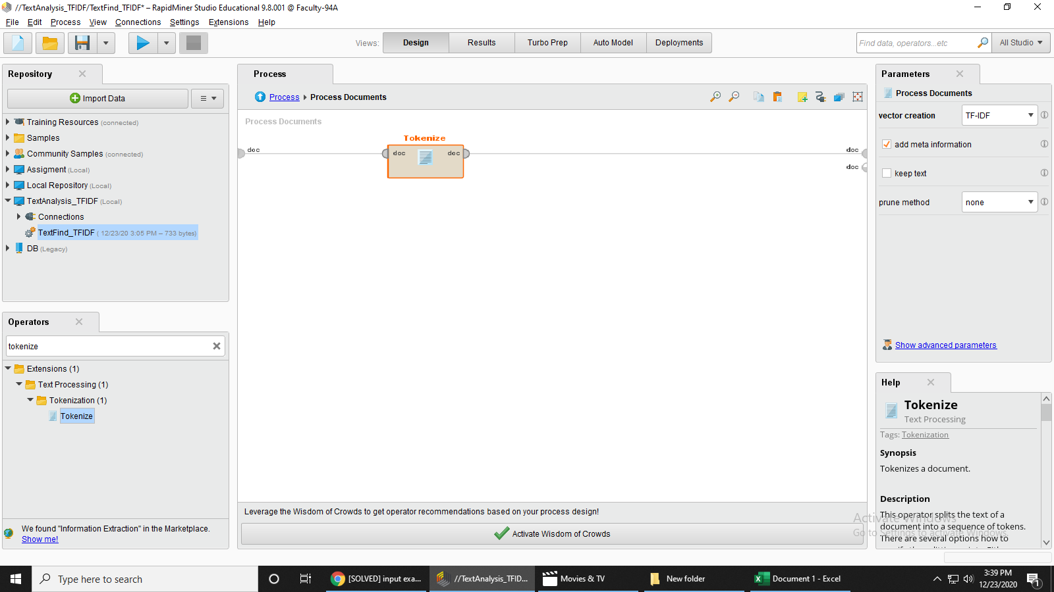Step 11: Make Connection in this way that the output of **Excel Document** goes input of **Spilt Example** and the output of **Split operators** goes to the input of **Select Attributes example** and the output of **Select Attributes** connect to the input of **Nominal Text** then the output of **Nominal Text** connect to the input of example set **Data to Documents,** the output of **Data to Documents** goes to the input of **Process Documents** and there are two output of process document the 1st example set output connect to the input of **Multiply operator** and the second word list output connect to the ***1st result node***. The 1st output of **Multiply operator** connect to the example set of **Generate TFIDF** operator and the 2nd output of **Multiply operator** connect to the ***2nd result node*** and finally the output of example set of **Generate TFIDF** operator is connect to the ***3rd result node***.



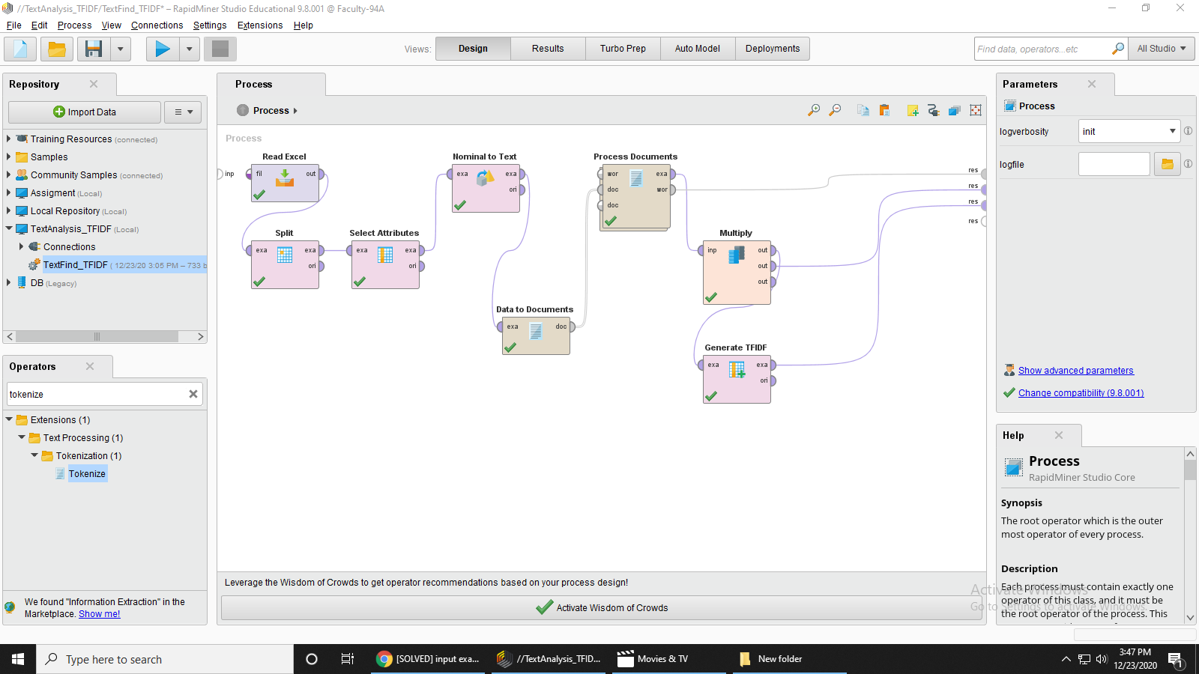

Step 12: Run the Process and it will give the result

